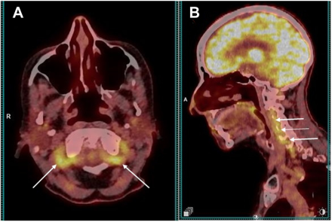

A 79-year-old woman presented with 5 weeks of newly onset headache, cutaneous allodynia, transient diplopia, and an unintended9-pound weight loss. C-reactive protein (CRP) was 32 mg/l (< 10 mg/l). A left-sided temporal artery biopsy was negative for GCA. 2-[18F]FDG PET/CT showed inflammation solely in the vertebral arteries (A, axial; B, sagittal, white arrows). Based on the provided images and clinical description please make an ophthalmic diagnosis for this patient. And output the diagnostic conclusions only.

**Large Vessel Vasculitis**